**Moderate to Severe Evaluation**

Sample_id : **NDCAPF(Cat)**

Link:<https://release.animalbiome.com/pet/assessment/report/summary/d8a228f1-6b36-40aa-991c-09936f5a8715>

Cats and dogs:

Any two of the following:

(

High Red Flag Megamonas OR (failed)

High Red Flag Sutterella OR (failed)

High Red Flag Collinsella OR (failed)

Low Red Flag Bacteroides OR (failed)

Low Red Flag Blautia (failed)

);

OR

Cats:

11 or more yellow flags;(failed)

OR 9 or more red flags;(**passed**)

High Red Megamonas,High red suttrella and collinsella failed.



Low group evaluation:

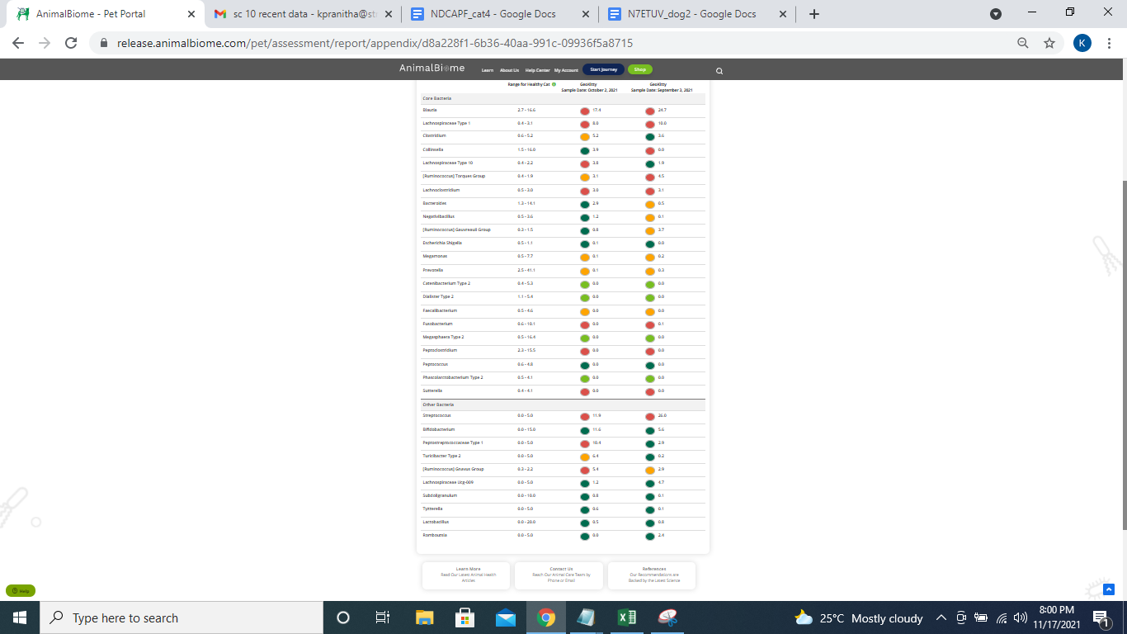

low red blautia : failed.

Low red bacteroides : failed (all conditions failed ) in the primary group.

Total yellow flags : 6

Red flags : 10

The result : **False False True**

Moderate to severe results:Pass

Expected result : **Moderate to severe**

Achieved result : **passed.**

